*GESTURE CONTROLLED MOUSE POINTER*

Ansh Vinod Motwani, Ayush Roy, Saumya Awasthi

Department of Information Technology

SRM Institute of Science and Technology

Chennai, India

# Abstract

This paper deals with controlling the mouse pointer and carrying out the functions of a track-pad with the help of hand gestures. Here we have tried to control the mouse pointer movement and click events of the mouse using our different hand gestures. Hand gestures were recognized using convolutional neural network. Following method mainly focuses on the use of web camera to develop a way to interact with computer using our hand gestures in a cost-efficient way.

# Introduction

PC innovation has massively grown over the previous decade and has turned into a vital piece of ordinary life. The essential PC hardware for Human Computer Interaction (HCI) is the mouse. The mouse isn't appropriate for HCI in some genuine circumstances, for example, with Human Robot Interaction (HRI). There have been numerous explores on elective strategies to the PC mouse for HCI. The most characteristic and natural strategy for HCI, that is a reasonable swap for the PC mouse is with the utilization of hand motions. This task is subsequently gone for examining and building up a Computer Control (CC) framework utilizing hand motions. Most workstations today are outfitted with webcams, which have as of late been utilized instability applications using face acknowledgment. So as to tackle the maximum capacity of a webcam, it tends to be utilized for vision based CC, which would adequately dispose of the requirement for a PC mouse or mouse cushion. The handiness of a webcam can likewise be extraordinarily stretched out to other HCI application, for example, a communication via gestures database or movement controller. HCI utilizing hand motions is instinctive and powerful for balanced connection with PCs and it gives a Natural User Interface (NUI). There has been broad research towards novel gadgets and strategies for cursor control utilizing hand signals. Other than HCI, hand motion acknowledgment is additionally utilized in communication via gestures acknowledgment, which makes hand motion acknowledgment much increasingly noteworthy.

Human Computer Interface mainly focus on the development of an efficient and easy to use interfaces. The personal computers have a variety of options to interact with different applications efficiently with the use of mouse, track-pad, Joystick etc. Nowadays touchscreen technology is available for devices like mobile phones. But this technology is still costly when used in the personal computers. And the devices currently used to interact are frequently breakable. Our objective was to make an alternative technology to interact with the computer which not as costly as the touchscreen technology and is easy to operate with.

Here we have tried to control the mouse pointer using our hand gestures and perform various tasks such as a single click, double click etc. We used a web camera to capture the real time image. We used the background elimination technique to eliminate the background images. These were then sent through the neural network and different gestures were recognized based on what type of gestures the neural network was trained with. From these recognized gestures we performed different actions such as tracking the mouse pointer, right click, left click etc. We tried to use the hardware that were cost efficient.

# Previous Work

The earlier versions of this project used colour strips to detect the different gestures. The mouse movements were made based on the movement of a specific colour. The combination of different colour strips led to detection of different actions to be performed. This was unfeasible as it is not always possible to carry colour strips. This led to the concept of gesture detection which can be made anytime.

# Requirments

Following are the basic requirements or tools that are used the development of the project:

## Software Requirements

* OpenCV
* Python 3
* Tensorflow
* Numpy
* Pillow
* TfLearn
* Imutils
* PyAutoGUI

## Hardware Requirements

* Minimum of 4GB RAM, (8 GB RAM recommended)
* Microsoft Windows 7/8/10
* Integrated Web Camera (1.3 Megapixels)
* 4 GB of available disk space minimum, 16 GB recommended
* 1280 x 800 minimum screen resolution

# System Methodology

Following are the steps we used:

* Capture the real time video.
* Extract the individual frames.
* Resize the frame.
* Flip the frames.
* Get the ROI (Region of Interest).
* Convert the ROI to grayscale.
* Blur the ROI.
* Eliminate the background.
* Predict the gesture.
* Draw the counters and calculate the center point.
* Track pointer according to the centroid movement.
* Perform different actions with the different colours extracted.

## Capturing the real time video

For the system to sense the movement of hand we need a sensor. We used the web camera in our work for that sensing. The web camera captures the real time video that is it gives us the real time news feed. The captured image is at a particular resolution and at a particular frame rate. We can change the frame rate and resolution according to our needs.

The web camera captures the real time video. This is divided into different frames. These frames are then processed further.

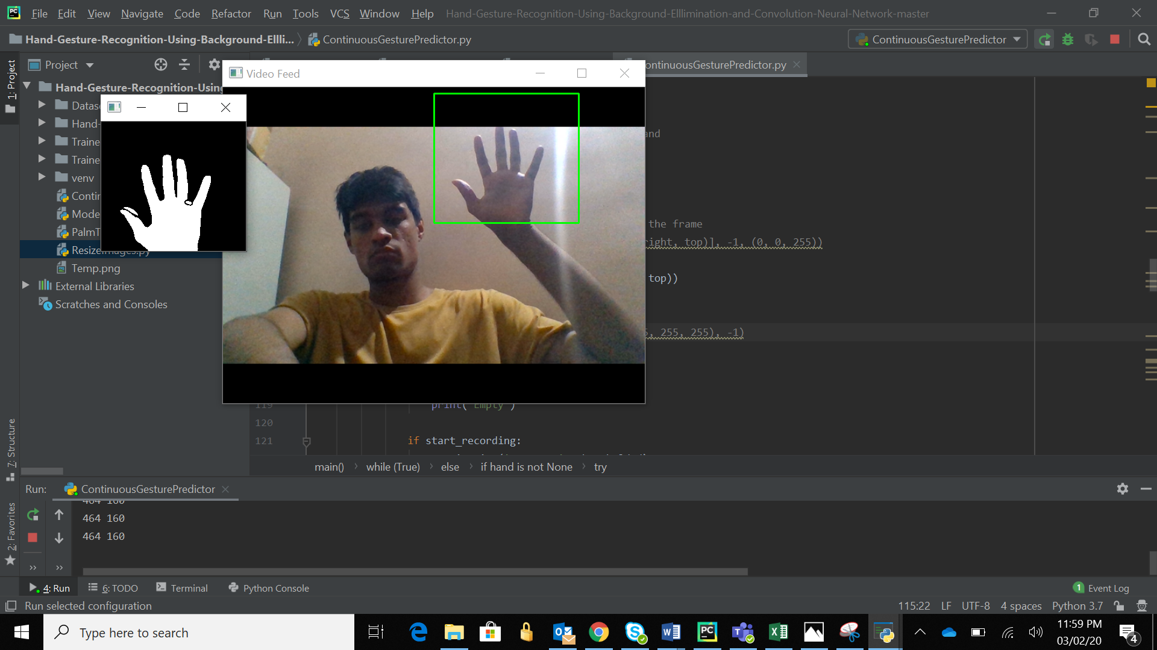

## Resizing the image

When the camera captures the real time feed and converts it into the frames then the frame obtained might be of different size. So, we need to resize the image to fit our need. Now this image is inverted. It is like the image we get when we stand in front of the mirror. So, if we move our coloured strip to right it will in turn move to left and so will our mouse pointer. This will create a lot of confusion in operating the mouse pointer. Hence, we need to flip each frame. This is done by vertically inverting the frame.

## Flipping the Image

Now this image is inverted. It is like the image we get when we stand in front of the mirror. So, if we move our coloured strip to right it will in turn move to left and so will our mouse pointer. This will create a lot of confusion in operating the mouse pointer. Hence, we need to flip each frame. This is done by vertically inverting the frame.



## Getting the Region of Interest

The Region of Interest is a small part of the entire frame which is the actual area where all the processing will be done. The remaining part of the frame is ignored. Only the image inside this region is processed. This is done to remove any unnecessary objects in the background which can cause noise.



## Eliminate the Background

In this step, all the background images are removed and only the image of the hand is shown. This is important as based on this image, the different gestures made by the hand will be predicted. The hand is shown in white colour and the remaining background is shown as black colour.



## Predict the gesture

The image then passes through our convolutional neural network. The gesture is predicted on basis of how the neural network is trained previously. This is an important step as a major part of the accuracy of our system depends on it.

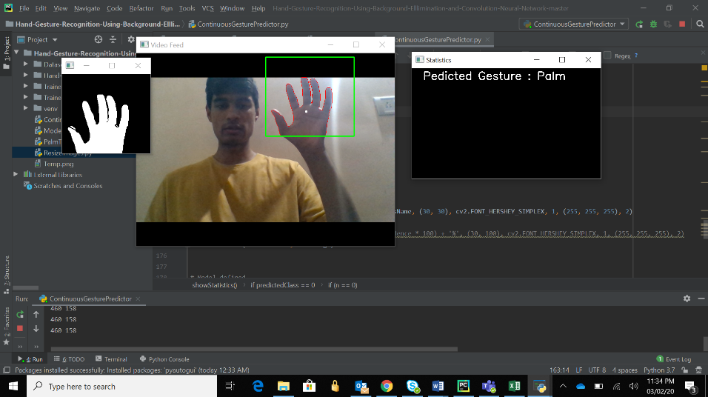

Figure Palm

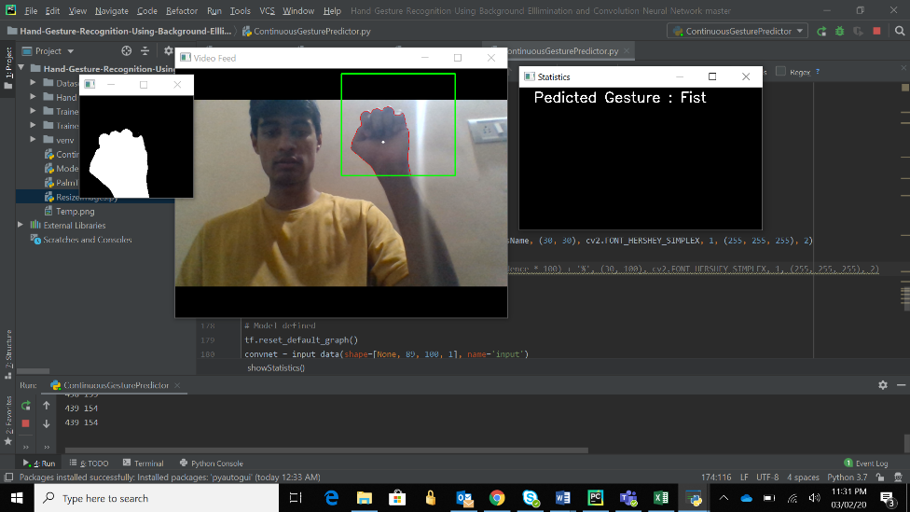

Figure Fist

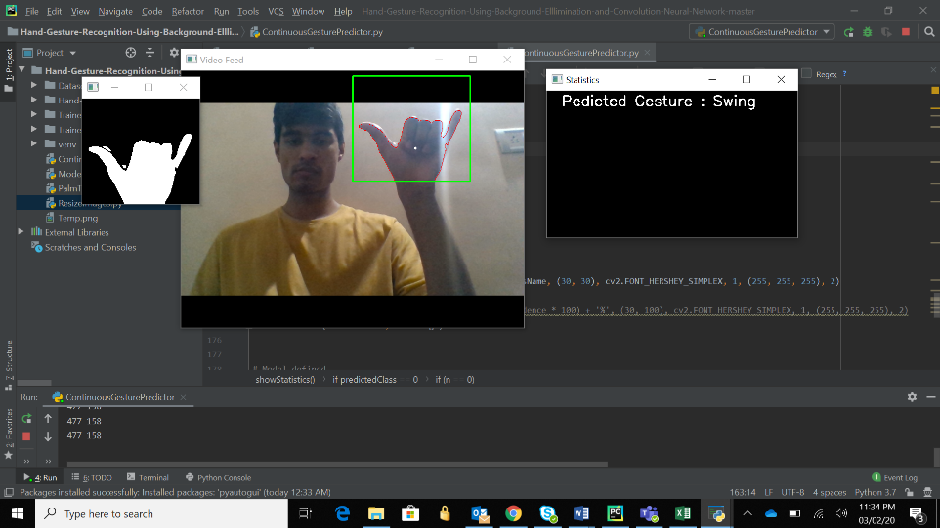

Figure Swing

## Draw the contours and its centroid

The contours are drawn around the hand gesture. Contour is the outer line around a certain area. After this we calculate the centroid. It is the centre point of the area surrounded by the contour. We control our mouse pointer movement with respect to the calculated centroid.

## Tracking and performing different actions

The tracking and different actions performed are done by the use of the inbuilt library in python named PyAutoGUI. This library has many functions for left click, right click or just moving the pointer and many more.

# Architecture Diagram

# Data and Results

Every gesture has a precision of above 95%. The system can easily distinguish between each of the different gestures. The system provides good results in both bright and low lighting conditions. The system needs a stable background to run as it uses background elimination technique to detect the hand. Also, it is preferred to have a solid background colour.

# Problems and Drawbacks

Since we have taken a region of reference so the hand needs to be in that region of reference for this to work otherwise it will not be able to predict the gesture. There should be no moving objects in the background as we have used the background elimination technique, so if there is a moving object in back it will consider it too. The hand gestures need to be done appropriately for the system to guess it more properly.

The framework may run slower on certain PCs with low computational abilities since a lot of complex calculations are done in a very short span of time. Although a standard personal computer has the required computational power for ideal execution of the framework. Another problem is that if the resolution of the camera is too high then the project may run at a slower speed. This issue can be resolved by decreasing the resolution of the captured picture by making changes in the framework.

# Conclusion

In this paper, we have developed a hand gesture-controlled mouse pointer by using web camera. We have used OpenCV and Tensorflow software to implement our project. Along with OpenCV we coded in Python language, we used convolutional neural network to recognise different gestures and we have used PyAutoGUI, an inbuilt library in python to programmatically control the mouse and keyboard. This technology has great applications in the fields of computer graphics, gaming, prosthetics, and many more. This technology can be used to help patients who are physically challenged. In case of computer graphics and gaming this technology has been applied in modern gaming consoles to create interactive games where a person’s motions are tracked and interpreted as commands.

Most of the earlier applications developed required additional hardware which is often very costly. Our aim was to create this technology in the cheapest all possible way and to create it on a standardized operating system. Various application can be developed using this technology with the minimum requirement of resources.

# Acknowledgment

##### The success and the final outcome of this project required guidance and assistance from different sources, and we feel extremely fortunate to have got this all along the completion of our project. Whatever we have done is largely due to such guidance and assistance and we would not forget to thank them.

##### We express our sincere thanks to the Head of the Department, Department of Information Technology, **Dr. G. Vadivu**, for all the help and infrastructure provided to us to complete this project successfully and her valuable guidance.

##### We owe our profound gratitude to our project guide **Ms. Deepanjali**, who took keen interest in our project work and guided us all along, till the completion of our project work by providing all the necessary information for developing a good system.

##### We are thankful to and fortunate enough to get constant encouragement, support and guidance from all the Teaching staff of the Department of Information Technology which helped us in successfully completing our minor project work. Also, we would like to extend our sincere regards to all the non-teaching staff of the department of Information technology for their timely support.

# References

1. Horatiu-Stefan Grif, Cornel Cristian Farcas, “Horatiu-Stefan Grif, Cornel Cristian Farcas” <https://www.sciencedirect.com/science/article/pii/S2212017316001389>
2. Gaurav Sahu, Sonam Mittal, “Controlling Mouse Pointer Using Web Cam” <https://www.irjet.net/archives/V3/i10/IRJET-V3I10233.pdf>
3. Heera Lal Bhadrecha, “Finger Gesture Control Computer Mouse With Image Processing” <https://pdfs.semanticscholar.org/4999/50dd0062ef2320fc84a46b10c5b04e8e2083.pdf>
4. Horatiu-Stefan Grif, Trian Turc, “Human hand gesture based system for mouse cursor control” <https://www.sciencedirect.com/science/article/pii/S2351978918304438>
5. [Kabeer Manchanda](https://ieeexplore.ieee.org/author/37403020600), [Benny Bing](https://ieeexplore.ieee.org/author/37275316400), “Advanced mouse pointer control using trajectory-based gesture recognition” <https://ieeexplore.ieee.org/document/5453841>
6. Kabid Hassan Shibly, Samrat Kumar Dey, Md. Aminul Islam, Shahriar Iftekhar Showrav, “Design and Development of Hand Gesture Based Virtual Mouse” <https://www.researchgate.net/publication/336304431_Design_and_Development_of_Hand_Gesture_Based_Virtual_Mouse>
7. Rachit Puri, “Gesture Recognition Based Mouse Events” <https://www.researchgate.net/publication/259625051_Gesture_Recognition_Based_Mouse_Events>
8. Onkar Yadav, Sagar Makwana, Pandhari Yadav, Prof. Leena Raut, “Cursor Movement by Hand Gesture” <http://www.ijesrt.com/issues%20pdf%20file/Archive-2017/March-2017/34.pdf> Kalyani Pendke, Prasanna Khuje, Smita Narnaware, Shweta Thool, Sachin Nimje, “Computer Cursor Control Mechanism by Using Hand Gesture Recognition” <https://www.ijcsmc.com/docs/papers/March2015/V4I3201582.pdf>